IKM ORACLE INCREMENTAL DELETE INSERT STRATEGY

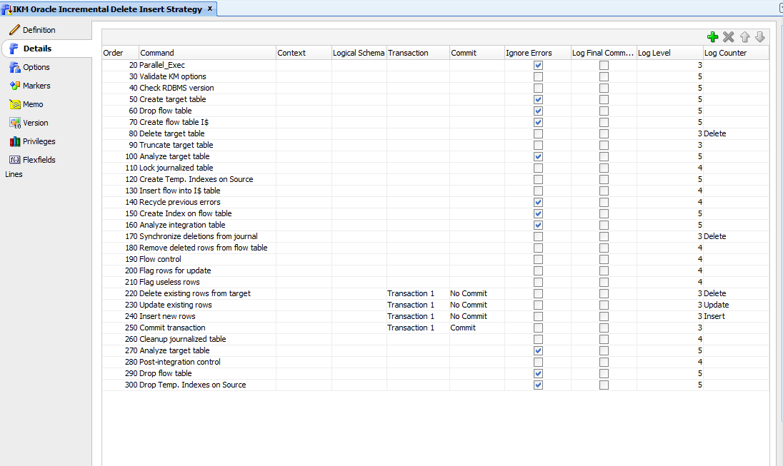

STEP TO ADD

Delete existing rows from target

ON TARGET ONLY

/* DETECTION_STRATEGY = <%=odiRef.getOption ("DETECTION_STRATEGY")%> */

delete from <%=odiRef.getTable("L", "TARG_NAME", "A")%> T

where exists (

select 'X'

from <%=odiRef.getTable("L", "INT_NAME", "W")%> I

where <%=odiRef.getColList("", "I.[COL_NAME] =T.[COL_NAME]", "\n\t\t\tand\t", "", "UK")%>

and IND_UPDATE = 'U'

)

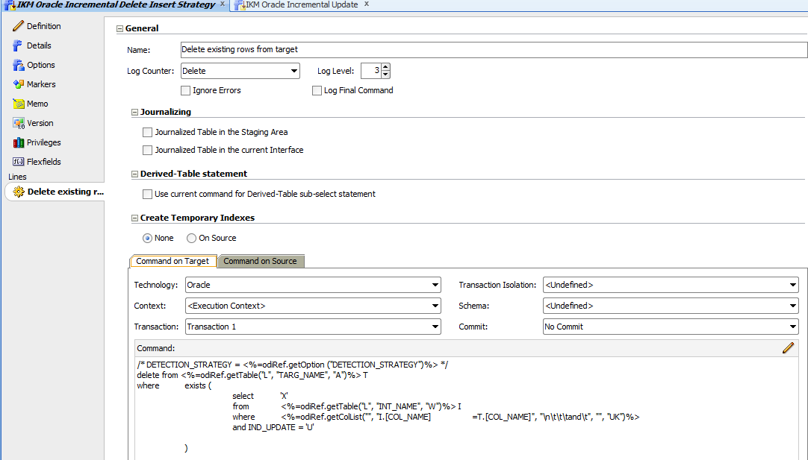

Update existing rows

ON TARGET

/* DETECTION_STRATEGY = <%=odiRef.getOption ("DETECTION_STRATEGY")%> */

update <%=odiRef.getTable("L", "TARG_NAME", "A")%> T

set

<? if (1==2<% out.print( odiRef.getColList( "|| 1==1 ", " ", "", "", "((UPD AND (NOT UK) AND ( NOT TRG)) AND REW)" ));%>){ ?> (

<%=odiRef.getColList("", "T.[COL_NAME]", ",\n\t", "", "((UPD AND (NOT UK) AND (NOT TRG)) AND REW)")%>

) =

(

select <%=odiRef.getColList("", "S.[COL_NAME]", ",\n\t\t\t", "", "((UPD AND (NOT UK) AND (NOT TRG)) AND REW)")%>

from <%=odiRef.getTable("L", "INT_NAME", "W")%> S

where <%=odiRef.getColList("", "T.[COL_NAME] =S.[COL_NAME]", "\n\t\tand\t", "", "UK")%>

)<? }; ?>

<%=odiRef.getColList(odiRef.getColList(",", " ", "", "", "((UPD AND (NOT UK) AND (NOT TRG)) AND REW)"), "T.[COL_NAME] = [EXPRESSION]", ",\n\t", "", "((UPD AND (NOT UK) AND TRG) AND REW)")%>

where (<%=odiRef.getColList("", "[COL_NAME]", ", ", "", "UK")%>)

in (

select <%=odiRef.getColList("", "[COL_NAME]", ",\n\t\t\t", "", "UK")%>

from <%=odiRef.getTable("L", "INT_NAME", "W")%>

where IND_UPDATE = 'U'

)

INSERT NEW ROWS

/* DETECTION_STRATEGY = <%=odiRef.getOption ("DETECTION_STRATEGY")%> */

insert into <%=odiRef.getTable("L","TARG_NAME","A")%> T

(

<%=odiRef.getColList("", "[COL_NAME]", ",\n\t", "", "((INS AND (NOT TRG)) AND REW)")%>

<%=odiRef.getColList(odiRef.getColList(",", " ", "", "", "((INS and !TRG) and REW)"), "[COL_NAME]", ",\n\t", "", "((INS AND TRG) AND REW)")%>

)

select <%=odiRef.getColList("", "[COL_NAME]", ",\n\t", "", "((INS AND (NOT TRG)) AND REW)")%>

<%=odiRef.getColList(odiRef.getColList(",", " ", "", "", "((INS and !TRG) and REW)"), "[EXPRESSION]", ",\n\t", "", "((INS AND TRG) AND REW)")%>

from <%=odiRef.getTable("L","INT_NAME","W")%> S